Adverse Medical Event Prediction System

Automated Test Cases

This document contains the results of the automated test cases for the Flask application 'Adverse Medical Event Prediction system'. "

The tests were executed using pytest and cover the basic functionality of the home page, prediction output, and the get_top_keywords function.

**Test Cases Summary**

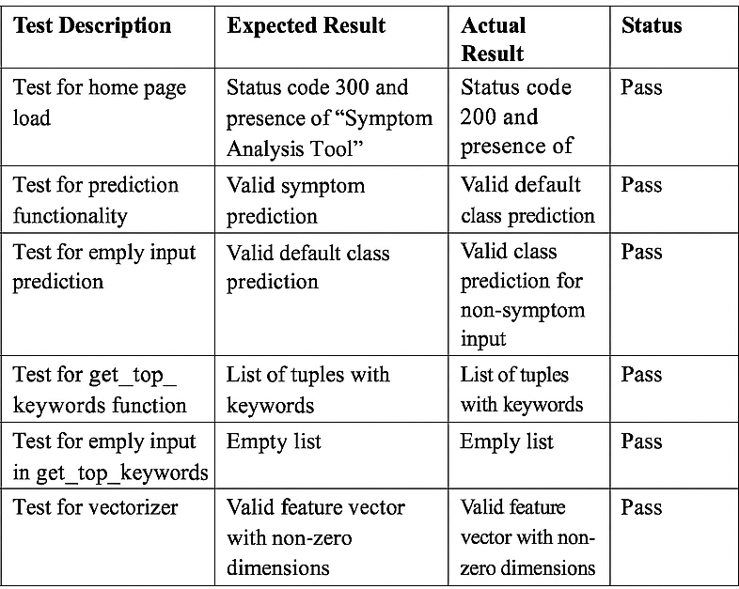

**Test Cases Output**

